Chapter 20
Breeding For Plant Resistance

Vertical vs. Horizontal resistance: how to breed for durable resistance
Vertical resistance of a plant to a pathogen is conferred by a single gene, referred to as a major gene, which often renders the host completely immune. Vertical resistance is typically characterized by the gene-for-gene relationship first described by Harold Henry Flor (Flor, 1942; Flor, 1955; Flor, 1971). This gene-for-gene concept has been elaborated in the literature as effector triggered immunity (ETI). Effector triggered immunity is actually the second line of plant innate immunity capable of response following pathogen invasion. The first is pattern triggered immunity (PTI).
Horizontal resistance may be referred to as generalized resistance. It represents host resistance conferred by multiple genes, called minor genes or polygenes. Each individual gene will usually only offer partial protection, which may then act synergistically with other partial resistance genes to offer broad spectrum resistance. Genes involved may be disparate in their function and intimately or only tangentially involved in plant immunity. For instance genes that determine the physical defenses of a plant body (i.e. bark, cuticle, cell wall, cell membrane etc.) affect horizontal resistance, as do many genes involved in the generalized immune responses; this includes genes involved throughout PTI, as well as downstream of R-proteins, as in ETI.
There are exceptions to the gene-for-gene paradigm where resistance is conferred by a single gene not correlated to a specific gene among the pathogen genome. One exception which may prove applicable to Cannabis agriculture, are MLO mutants (Pepin et al, 2021). In a number of other crop species mlo mutants provide durable, single gene mediated resistance to powdery mildew. MLO is likely a regulatory gene in plants. A mutation of MLO results in myriad phenotypic changes, some of which reduce susceptibility to the pathogen. Rather than producing a specific protein to interact with a corresponding target of the pathogen (gene-for-gene), MLO mutants have physically altered structural architecture among their plant tissues which confers increased resistance to PM, including thickened cell walls.
The multigene nature of horizontal resistance makes it more durable to pathogen evolution. If a crop species is developed that confers pathogen resistance based on one vertical resistance gene alone, it will be highly susceptible to quickly being overrun on the treadmill of evolution by the corresponding pathogen.
On the other hand, the logistics of breeding for vertical resistance are much simpler and quicker: resistant plants will segregate easily into resistant and susceptible populations, the two potential phenotypes conferred by a single gene loci. Plant resistance genes involved in gene-for-gene resistance, or ETI, are usually, but not always, autosomal dominant when expressed. This means they are not sex linked (autosomal chromosomes are all chromosomes in a species that are not sex chromosomes) and that the plant will be resistant even if it only inherits a single copy of the gene (allele) from one parent, rather than having two copies of the gene for resistance (homozygous for the resistant allele). This is the case with the recently identified allele, PM1, an autosomal dominant gene conferring resistance to powdery mildew caused by Golovinomyces ambrosiae which probably codes for a NB-LRR class of protein (Mihalyov and Garfinkel, 2021). If one wants to ensure a variety is true-breeding for disease resistance, progeny testing must be performed to ensure potential parent plants are homozygous for the dominant resistance allele; inbreeding may be performed to create homozygous lines.
Breeding for horizontal resistance is a much more elaborate and nuanced affair. The increased effort and time may be justified by the potential longevity inherent in a multigene basis for resistance in the face of pest and pathogen evolution. Generally the first round of selection will focus on partially resistant plants within the target population. Fully resistant plants likely exhibit the more complete, but less durable vertical resistance and are discarded. Whereas partially resistant plants are able to overcome the pathogen with numerous, incompletely effective resistance genes. These numerous, incomplete resistance genes likely differ among partially resistant individuals, particularly if the breeding population is sourced from diverse germplasm. Therefore, successive rounds of inbreeding with selection among these partially resistant plants may then accumulate as many partial resistance genes as possible into a single lineage. Horizontal resistance is strengthened by this accumulation of partial resistance genes in a desired cultivar by increasing the magnitude of resistance and the broadness of mechanisms.
Further increased durability of resistance in lines may be achieved by stacking multiple vertical resistance genes and/or combining vertical resistance genes with horizontal resistance.

Planting Resistant Crops
If one is successful in creating a cultivar resistant to one or more diseases, this cannot be seen as a greenlight for monocropping such a variety. In fact doing so would be the fastest way to undermine the great achievement such a variety would represent, particularly if resistance is conferred by a single vertical resistance gene. Breeding a plant capable of reducing or eliminating a disease which affects it is a form of biocontrol (Cook and Baker, 1983) (Fig 19.1). A characteristic of all biocontrol agents is that they involve at least two, usually more, interacting species which exist under the continuing action of natural selection.
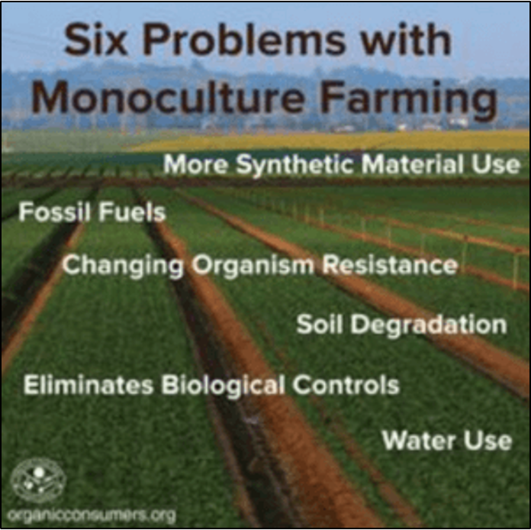
Figure 20.1. Poster released by organicconsumers.org depicting 6 of the most imminent dangers of monocropping any plant.

Monocropping a resistant variety of any plant has two most probably potential outcomes: extinction of the pathogen (or at least its virulent race), or nullification of the new plant host resistance by unsusceptible, virulent pathovars (either present in the original population or the result of emergent mutants). If the disease organism has no refuge among alternative species or wild relatives of the cropped species within a region and does not persist long without a suitable host, the disease causing organism could successfully be extirpated from a locality or even driven to extinction.
Total extinction of a pathogen is an unlikely prospect, however local or regional extirpation could be possible following an enormous concerted effort. This in fact may be among the best options for isolated growers and those with intensive environmental control. On a broad scale, intensive efforts towards the complete elimination of an agricultural pest species have been spectacular failures historically, such as occurred with wheat rust and barberry (though American barberry, the alternate host of wheat rust, was almost driven to extinction). Additional difficulties apply to Cannabis due to the legal grey area in which it exists in many locations. This leads to the proliferation of clandestine cultivation spaces whose cultivators are prevented from collaboration with and support from extension agencies, and who escape any biological quarantine laws by the nature of their existence.
It would seem ideal for an entire field under cultivation to possess traits which help protect against pests and pathogens. If such traits have been identified within the species, there are several technical details that make this both difficult to attain as well as questionably effective. Combining a variety of pest and pathogen resistance traits from varied lines into a desired cultivar while maintaining the desired character of the original cultivar is a difficult process, necessitating many generations of breeding to attain, if success is in fact ever attained at all. If, knowing the difficulty of this path, one chooses to pursue this goal anyway, they must first determine what variety of resistance to pests and pathogens exists in their available breeding stock. To do so, representative lots of seed are grown under conditions where the pest and pathogens of concern are either naturally present or introduced. Following evaluation, if desirable resistances are identified, an important distinction arises: are these qualitative (vertical) or quantitative (horizontal) traits?

Multilines:
Rather than attempting to produce singular cultivars resistant to all known pests and pathogens, multiline seed varieties are a common tool utilized by mainstream agronomists to reduce economic losses due to pest and disease pressures, as well as variable abiotic stressors including weather and soil fertility. Multilines are produced by mixing seed from a variety of individual cultivars together to be planted as a single crop. Multilines may comprise strains that are nearly identical in agronomic characteristics, but only differ in one trait (disease resistance for example). Such “sister” lines are known as isogenic lines. Alternatively, multilines may comprise vastly differing varieties for both agronomic character and disease resistance.
The use of multilines can sidestep many of the aforementioned breeding issues that arise when one attempts to combine varying sources of disease resistance into a single, desirable cultivar. Multiline plantings buffer economic locesses from pest and pathogen damage that may occur during each individual season, while slowing the emergence of resistant pathogen races over time.
When disease affects plants in a multiline planting, it is unlikely that the pathovar will be virulent on all of the varieties chosen to make up the multiline (when they have been chosen specifically for variability in resistances to pathogens). Affected plants will experience reduced growth, thereby limiting competition for nearby plants in dense field plantings. Since it is likely many of these nearby plants are resistant to the pathogen, their increased growth will help to make up for the diminished yield of the infected plant.
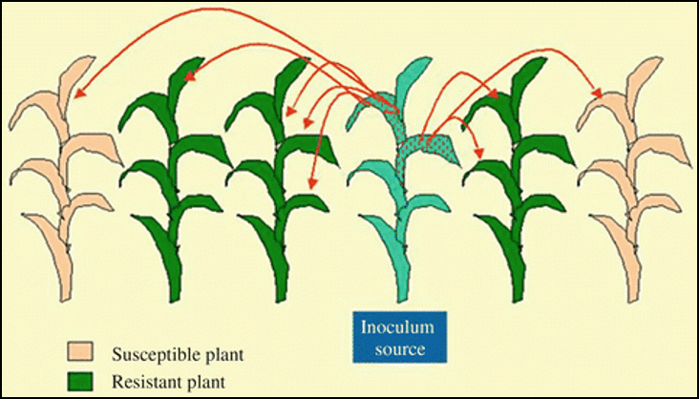
Figure 20.2. Seed lots must be tested in fields with pest pressure to determine a given genetics’ resistance to particular pathogens. Reddy 2017.

Additionally, the amplification of pathogen populations in the field is slowed by resistant plants. Not only are pathogen spores which land on these plants are no longer a threat to the crop, but any further population amplification that would have occurred had a susceptible plant been infected is prevented (FIg. 19.2). Both within-season disease pressure, as well as the likelihood of resistant pathogen races overcoming crop resistance, are reduced with the use of miltilines; by providing pathogens resistant plants to survive on each season, it removes the selective pressure that would otherwise quickly move the pathogen population towards renewed virulence among newly developed resistant plant cultivars.
In most cases Cannabis farmers must adhere to certain market parameters which demand product uniformity in chemotype, structure, and processing requirements. This may be relaxed somewhat for crops destined to be bulked together and extracted. Flower farmers, on the other hand, need near complete uniformity and will only adopt multilines that are homogenous in all traits other than disease resistance. The use of multilines for flower farmers at scale may necessarily be restricted by market demand to isogenic lines homogenous for specific characters, if such seed lines may be developed. Alternatively, farmers that require purity of variety through harvest, processing, and marketing can interplant rows of different varieties in a controlled fashion to approximate some of the benefits of multilines, while maintaining the ability to harvest individual cultivars separately. On the other hand, extract and commodity scale farmers who plant multiline fields may benefit from the additional advantage conferred by the variable culture preferences among agronomically diverse variety mixes; growth differences among cultivars in response to variable stresses beyond the farmers control (i.e. weather) will favor varieties within the multiline that do well in any given year at the expense of those that prefer differing conditions. The effect is to offer relatively consistent production from a multiline field, regardless of the conditions in any given year, as opposed to the boom-or-bust potential of a monocropped field.

Monocropping:
Monocropping can be a highly efficient farming method that permits predictable planting and harvest cycles and the standardization of farm equipment. However, monocropping has some serious drawbacks, particularly in the arena of pest and pathogen problems. Crop failure for a monocrop farmer of a single species (or even a single cultivar) can be devastating.
The most famous example of monocropping folly is the Irish Potato Famine. The famine, caused by the Oomycete Phytophthora infestans, devastated the island's potato crop. Due to socio-economic reasons the potato was an essential, staple food crop for the majority of the Irish population. The resulting crop failure led to the deaths of over one million Irish and massive emigration.
A similar crop failure almost happened to the corn crops in the United States in the late 1960s and early 1970’s. At the time most of the corn varieties cultivated in the U.S. relied on the same mother plant cytoplasm (The reason for this was that the seed bearing plants all shared a mitochondrial gene conferring male sterility. This allowed hybrid seed to be produced by pollinating these male-sterile females with a different male variety without the need to manually detassel every mother plant). A pathovar of Helminthosporium maydis (southern corn leaf blight) emerged and was able to infect all varieties that relied on this cytoplasm. In order to overcome this pathogen, resistant varieties of corn had to be developed in order to avoid ongoing, devastating losses to blight. Ultimately, this was the same solution required to overcome late-blight in potatoes.
Worldwide, our agriculture system has been losing diversity -both in the number of staple crops and the diversity within each crop species. It may be argued that the traits being culled from our crop species are unnecessary or maladaptive for the purpose for which the crop is being developed, and this may well be true in most cases. However, we should be aware of the possibility of unintentional loss of favorable characters, particularly disease resistance. Such traits may not be under selection in our crop production systems during cultivar development, but may suddenly become important factors in the face of emerging plant diseases. The loss of characters desired by consumers, such as flavor, may also occur if the stakeholders determining breeding direction deprioritize it from the gene pool; this is often the complaint that plagues modern supermarket tomatoes. Let's not make the same mistakes with Cannabis.
Cannabis farmers often rely on their Cannabis crop alone as a source of income. While singular specialization can improve economic efficiency under certain conditions, hence the ubiquity of monocropping in modern agriculture, over the long term it would be wise to diversify. Whenever possible, diversification should include venturing into alternative crop species, including crop rotations. Not only will this reduce possible pest/pathogen outbreaks and accumulation, but it will also increase soil fertility by improving the soil structure and fostering a microbial community capable of solubilizing and chelating otherwise inaccessible soil nutrients.
In addition to crop rotations, farmers may reduce disease pressures by diversifying within the Cannabis genera. This starts in the field by choosing to plant cultivars known to be resilient to pest and pathogen pressures a farmer is likely to face, and that differ among each other in these respects. For some pests, susceptible Cannabis varieties may also serve a role as litmus plants themselves; serving as sentinels for the presence of disease to allow early corrective action by the farmer (these plants should be monitored for pests and removed as trap plants when appropriate).

Agricultural systems reliant on intense monocropping results in increased disease pressures and depleted soil nutrient availability compared to polyculture systems. The resulting imbalance necessitates the application of evermore pesticides and exogenous nutrients to maintain the same level of productivity. Biodiverse farms, like biodiverse ecosystems, buffer losses and blunt the severity of disease outbreaks, improving the resilience of the whole.

Exceptions to the rule:
There are successful agricultural precedents for utilizing monocropping to improve crop health. The following concept and examples rely on a distinct mechanism from that of genetic resistance. Rather than completely eliminating pathogen organisms through absolute exclusion achieved by genetic resistance of the host, biocontrol is accomplished through accumulation of hyperparasites (parasites of other pathogenic/parasitic organisms) or competitors of the pathogen. Persistent monocultures have been successfully used to control various plant diseases.
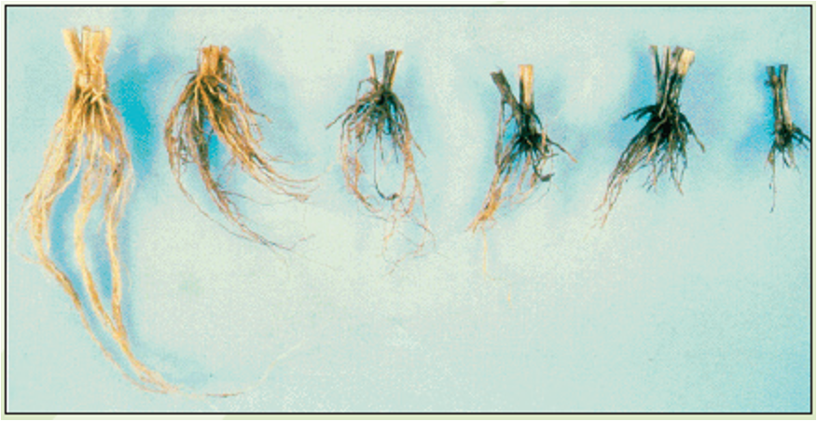
Figure 20.4. Wheat crowns and roots infected with G. graminis of increasing severity (left to right)

In the Pacific Northwest repeated cultivation of the wheat monocultures have been used successfully to control take-all. Take-all is a disease caused by the fungus Gauemannomyces graminis var. tritici. Soils suppressive to take-all can develop when wheat is continuously grown in the same field over the course of several years. The first crops will succumb to progressively less incidence of take-all loss. The microbial ecology is shifted in the presence of the disease towards microbes parasitic to G. graminis var. tritici. Once established these parasites create a suppressive soil, which prevents disease outbreaks among subsequent plantings. This soil can even be used as inoculant to transform non-suppressive soil into suppressive soil.
Suppressive soils have also emerged among other crop systems where repeated monoculture has been used. Repeated cultivation of the same Rhizoctonia solani susceptible crop selects for pathovar specific antagonists capable of quickly reducing disease severity in subsequent plantings (Cook and Baker, 1983). Similarly, A research breeding plot at the University of Minnesota known to be infested with potato diseases was rendered ineffective as a screening tool for susceptible varieties after the soil developed a microbiome suppressive to potato scab (Streptomyces scabies) and Verticillium wilt (ASM: Meet the microbiologist, March 26, 2020).
In another agricultural plot where lettuce was being bred over several decades, all lettuce growing in the area became infected with leaf mosaic virus, although the varieties had all developed tolerance and showed no ill effects of the virus (Harold personal communication). Unfortunately, this virus is seed borne and the tolerant lettuce lines are capable of introducing the virus in areas where susceptible lettuce is being grown.
In some systems, as in take-all monoculture biocontrol, the emergence of suppressive microorganisms is dependent on the presence of a pathogen population first, likely indicating the suppressive organisms are obligate hyperparasites. Hyperparasites is a term which describes parasites of parasites or pathogens of other host species. Among many other soil pathogen-host plant systems, suppressive soils can be cultivated without prior host cultivation or pathogen infestation in the location. Where this is possible, the organisms responsible for pathogen suppression are likely generalists. The indigenous microbiome in soil may prevent pathogen invasion indirectly through competition, or directly via excretion of antibiotic compounds, and/or facultative (opportunistic) hyperparasitism of the pathogen.
The same principle could apply for soils in which Cannabis is successively grown. However, it should be noted that this change in soil microbiome populations may favor either pathogens or beneficial organisms, depending on conditions. Beneficial microorganisms are those that promote plant growth and/or inhibit disease causing organisms. Mycorrhizae, for instance, will accumulate over time in soils cultivated with appropriate host species. Mycorrhizae may reduce pathogen and pest susceptibility by improving host plant growth through improved nutrient acquisition (mainly phosphorus), physical exclusion of pathogens from the rootspace, and an induced systemic resistance in the host plant (Mycorrhiza Induced Resistance). However if population densities or soil conditions favor pathogen growth, successive Cannabis crops may simply further build the pathogen population in the soil, creating a cycle of worsening problems. For this reason some have cautioned against producing mycorrhizae inocula on the same host species for which inocula is destined for application (mycorrhizae is an obligate symbiont, and requires a live plant host for growth and spore production). This is a reasonable solution to the potential problem of accidentally amplifying and introducing pathogens to Cannabis crops (at least pathogens restricted to Cannabis). However, this is unnecessary if mycorrhizae inocula are produced from pathogen-free Cannabis plants, as in successive cropping of pathogen-free Cannabis in the same soil.

Pathogen and Pest Evolution
The more likely outcome of extended monocultures, which is the rule that proves the aforementioned exception, is that the pests and pathogens will evolve to overcome the defenses of the resistant cultivar. By planting only resistant plants, this wall of resistance creates a strong selective force. This will result in the demise of all pathovars incapable of overcoming the source of host resistance. However, if as little as a single individual among the pathogen population is capable of causing infection despite resistance among the host plant population, it will be ‘selected.’ The offspring of such still-virulent pathovars will quickly replace the avirulent pathovars unable to penetrate the resistance wall. In this manner, the wall will only have been overcome by the resilient, virulent pathovars who will persist to form the basis for a new pathogen population.
This scenario represents a rapid evolutionary change of the pathogen population. The ability of some pathogen individuals to overcome newly encountered plant resistance is the result of gene alleles which vary slightly from those in the genomes of other pathogen individuals in the population unable to infect resistant plants. This variation, which exists across individuals among most populations of any species, is the essential prerequisite upon which natural and artificial selection act. Directional selection among the pathogen population quickly nullifies the usefulness of the prized resistant plant cultivar which took much effort to produce. Maintaining a variety of cultivars with differing levels and/or mechanisms by which they achieve resistance helps to slow the selection towards resistant pathogen populations. Depending on the genetic nature of the resistance of the host and the virulence of the pathogen, there are a range of management strategies recommended to prevent or slow the emergence of resistant pathogens. Among these, most share a theme of increased diversity; among the cultivar variety interplanted in a region or farm, among mechanisms of genetic resistance to pathogens possessed by chosen cultivars, and in the exogenous management options applied to the crop (beneficial biologicals and pesticides applied by the farmer during growth).
Farmers recognize that some crop loss to pests or pathogens is inevitable. While it is desirable to minimize this loss, it should be accepted that not every (or any) cultivar you plant will be 100% resistant to all possible pests and pathogens. Managing a more diverse farm requires more planning and labor than monocropping, but has better potential for higher -and more stable- productivity over the long term.

Natural Sources of Resistance
While prone to the same potential obsolescence when placed in the highly artificial environment of an agricultural field, natural resistance genes found in the worldwide Cannabis gene pool likely offer more resilient mechanisms of protection than individual gene transfers resulting from GMO technology, particularly as sources of host resistances of quantitative nature. Some crop-pathogen interactions leave the agriculturalist with no known sources of natural resistance among sexually compatible populations. The papaya, Carica papaya, for instance is susceptible to papaya ringspot virus. There is no natural resistance to ringspot virus known among all papaya germplasm. Genetic modification was used to create resistant varieties utilizing a variety of novel mechanisms (siRNA, etc). Closely related species are resistant, but are sexually incompatible. Efforts are underway to create fertile intergeneric hybrids among papaya and Vasconcellea in order to create resistant varieties of non-genetically modified germplasm. This method has its own load of problems from the perspective of the agriculturalist. It shares all the same problems that arise from the use of sexually compatible but unimproved wild varieties as genetic sources of a desired trait. These issues will be discussed below.
For many crop species, Cannabis included, there are refuges of wild varieties within the same species or sexually compatible related species. Cannabis is extremely variable, hence one of the reasons there has been so much disagreement among botanists as to what the species delineations within the Cannabis genera even are (Shultes et al. 1975, Small and Cronquist 1976, McPartland 2018). Agricultural institutions often keep libraries of wild germplasm and resistant varieties of crop species. Much of the United States supply of hemp germplasm was destroyed in the hysteria of the 1970’s drug war (OSU personal communication). Luckily, Cannabis is a resilient species that persists in many regions of the world as feral populations, including populations in the midwestern United States derived from hemp cultivated over half a century ago. Additionally, local farmers maintain landrace varieties in many regions to this day. This is continuing to decrease, however, as traditional varieties are replaced by increasingly accessible modern cultivars derived from very restricted founding populations.

Table 19.1. Variety of Cannabis germplasm which may be available to modern breeders.
Undomesticated: Wild | Natural occurring populations that have never been under cultivation
Semi-domesticated | Varieties that are planted and/or cared for by humans, but are not significantly different from their wild counterparts
Domesticated: Landrace | Open pollinated populations developed in relative isolation by regional farmers
Domesticated: Cultivar | Varieties bred by humans towards a specific, desirable type plant. Distinguishable from the wild ancestor and may have lost the ability to survive without human assistance.
Feral: Naturalized, Introduced, Invasive, Escaped, Exotic | Varieties which have escaped cultivation and may successfully reproduce without further human intervention. Often traits selected for during domestication revert to wild-type traits (atavism) that increase reproductive success in the wild.

Cannabis is unique among crop species, in that it has had a long history of clandestine, isolated cultivation. Isolation of gene pools is a prerequisite which permits divergent evolution, resulting in a variety of type and form among separated populations. This long history of isolated cultivation of varieties derived from a restricted founding population of elite plants selected from landrace populations, combined with the rise of indoor growing, has likely resulted in the inadvertent loss of many disease resistance genes from Cannabis cultivars grown in the West. Disease resistance represents a cost to the plant; in the absence of that disease plants that do not waste resources protecting themselves from a nonexistent threat may be more biologically fit (more likely to reproduce). This possible effect of Natural Selection is compounded by the effect of genetic drift in small breeding populations. After many generations of bottlenecked reproduction, often through a single pair of parents -or now with the widespread application of sex reversal, a single parent,- covert disease resistance genes are readily lost by chance. This is a particular risk for genes that confer resistance to rarely encountered disease or pest organisms, as well as abiotic stressors. Generations of inbreeding under idealized indoor conditions will likely purge a lineage of genes that improve fitness in outdoor environments that experience extremes in temperature, water, and light stress. This may happen by chance, or through selective pressure if relevant genes reduce their desired performance of the variety under the idealized indoor condition (either by artificial selection due to breeder selection or natural selection due to reduced reproductive fitness under the cultivation system). Resistance genes are often a fitness cost to the host plant in the absence of the relevant pest and are readily lost in the absence of pest pressure.

Issues with Introgression:
Introgressing genes of interest from a foreign line into a desired cultivar will also introduce a lot of unwanted genes that will alter the desired agronomic characteristics of the cultivar being improved. A line chosen as the donor parent of the trait to be introduced should be as close to type as the cultivar to be improved as possible. The more different in character it is, the more work will need to be done in subsequent generations to return the cultivar to type while retaining the introduced trait. This often involves backcrossing the resulting progeny back to the desired cultivar (the recurrent parent). This can be done as many times as desired in order to remove as much unintended introduced genetic material as possible from the improved cultivar.
Each backcross generation reduces the amount of introduced genetic information by half, so that the F5 generation only contains about 3% of the donor line's genetic code. Regardless of how many backcross generations are performed, part of the donated genome will represent the gene(s) which code for the introduced trait, because that trait will be selected for at every generation. DNA flanking the target locus or loci will be the most persistent non-target DNA from the donor variety to remain through multiple generations of backcrossing. The increased likelihood of two genes to segregate together during meiosis is known as linkage. The strength of linkage between any two genes measured by the chance they are chromosome of they both are a part; if gene loci are on different chromosomes, they are not linked and segregate independently of each other.
Once a breeder reaches a desired level of purity in the cultivar to be improved, which may be as soon as the F1 generation or after a series of backcrossing, the line may be inbred to fix the introduced trait. Backcrossing will never fix an introduced trait into a line because all backcross progeny will be heterozygous for the trait of interest (which has been introduced by the nonrecurrent parent). In order to achieve a line homozygous for an introduced trait, inbreeding must be performed.
Backcrossing is useful for the introgression of a trait into a homogenous line. Backcrossing will not stabilize a clone-only plant in seed form unless the original clone is highly inbred already. If you start with a highly heterozygous recurrent parent, heterozygosity will be restored at every backcross generation. You can succeed in introgressing the male chromosome into a seed population that is otherwise mostly derived from the desirable clone parent. Exactly this is commonly performed among Cannabis breeders. However this is not an inbred line and will not breed true, rather this is a heterozygous family derived from the parent clone. You will have progeny clustered around the parent type, but quite varied nonetheless. Hypothetically, two inbred lineages could be derived from a clone, each fixed for opposing alleles at each heterozygous loci. If these are then crossed back together their seed all grow out a copy of the original clone. Practically, this is numerically impossible for a breeding program.

